Steps to connect Visual studio code to GitHub:

Steps to Sync visual studio code with your git hub account:



1. Download visual studio code:
2. Download codespace

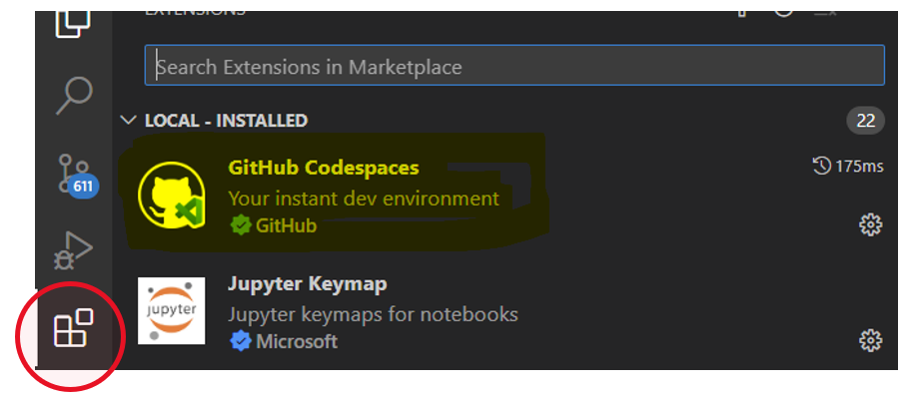



1. You will see the below symbol added in visual studio code’s left bar menu: ‘Remote Explorer’

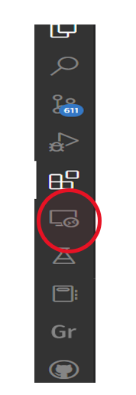

1. Click on remote explorer and go to codespaces option and try to select GitHub branch of your interest:

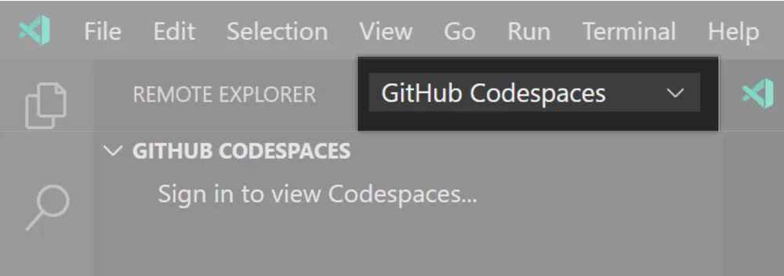



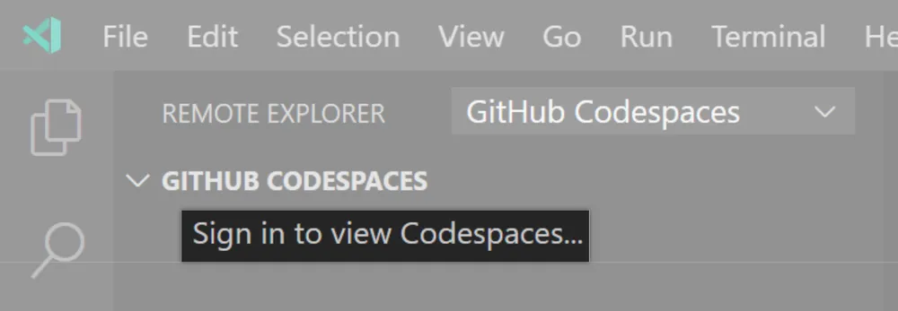

1. To authorize VS Code to access your account on GitHub, click Allow.
2. Sign into GitHub to approve the extension.
3. Back in your visual studio code select main branch and storage options as below:





1. Finally, you can see the same code files present in your GitHub repo:

